4

Analyses of Torsionally Loaded Components

Exercise 1

* Create the extruded segments of the multi-segment shaft

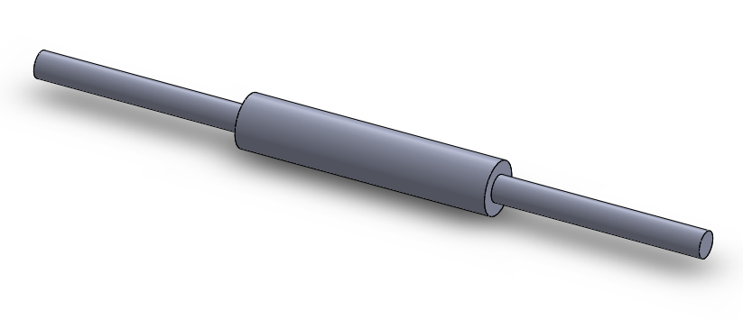

* Complete the simulation study
  + Convert the extruded segments into beam elements as done in Chapter 4’s case study

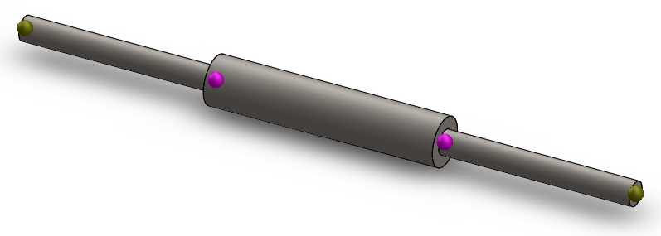

* + Apply material (AISI 1010 steel)
  + Apply the right constraint (fix supports at joints A and D)
  + Apply torques at joints B and C

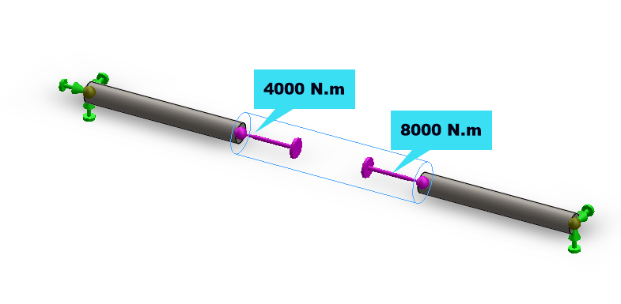

* + Run the study to get the solutions/results

**Shear stress**

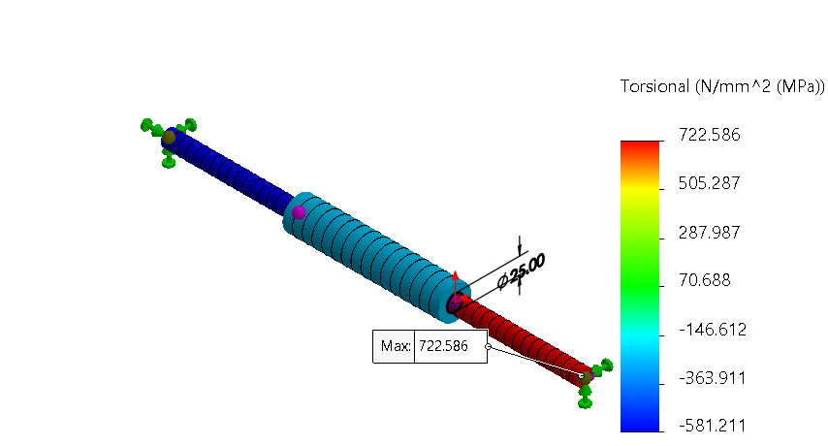

**Angle of twist**

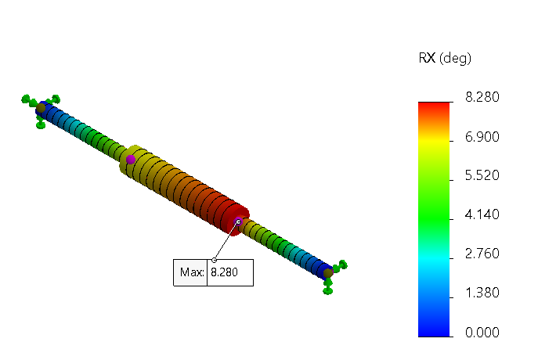

Exercise 2

* Generate the extruded model of the shaft (using an assumed length of say, 500 mm). *NOTE: Both the axial and shear stress that will develop in the shaft are independent of the length, so any length you use should be OK for this exercise.*
* Create the simulation set-up, then apply material, fixture, and load

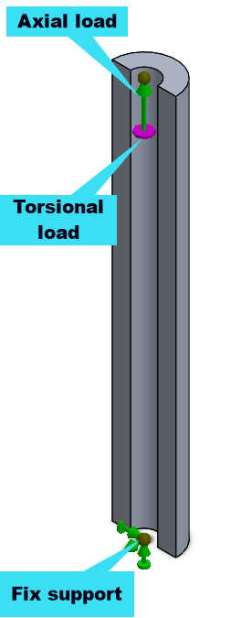

* Complete the solution
  + **Maximum shear stress**

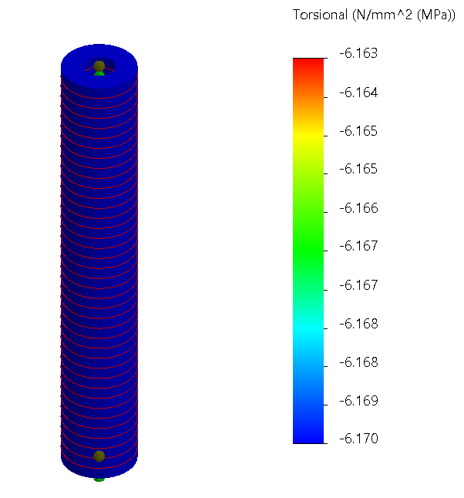

* + **Minimum normal stress**

